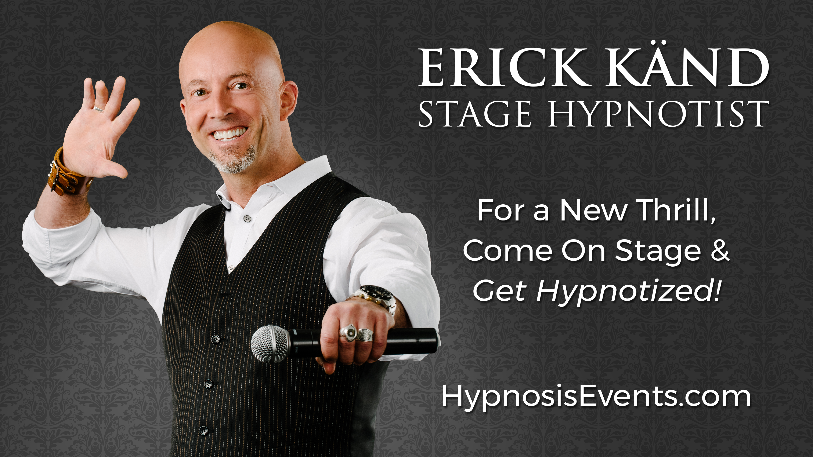

Erick Känd has hypnotized over 20,000 people worldwide. He’s performed in EVERY state of the USA. Check out his YouTube channel, it has over 4 MILLION views!

Get Hypnotized! The Erick Känd Comedy Hypnosis Show is an outstanding program of interactive entertainment guaranteed to have you laughing out loud and applauding wildly. The show is fast-paced, hilarious, and head and shoulders above the traditional Hypnosis Show. Self-selecting volunteers experience true hypnosis phenomena and become the true stars of the event! The stage is filled like a big production with “cast members” drawn from the audience. Music and sound are an integral part of the performance, making it a headline experience with a big impact.

Erick radiates confidence to his volunteers, and encourages them to display their talents while ensuring each performance appeals to the tastes of everyone.

While some Stage Hypnotists claim to be “Certified” Hypnotists, most are “winging it” with little depth to their Hypnosis training. Erick portrays Hypnosis in a positive light while treating participants with the courtesy and respect they deserve. Expect an unforgettable experience, and people will be saying, “I was skeptical, but now I’m a believer!”

